COMPUTER NETWORKS LAB
TASK 6
ENCAPSULATION AND OVERHEAD
CALCULATION
Ethernet • Network layer • Transport layer • Payload efficiency

Name | Kasireddy Srihitha
Roll Number | 2520030153
Section | Sec - 7

1. AIM
To inspect one TCP packet and one UDP packet in Wireshark, identify their link-layer, network-layer and transport-layer header lengths, calculate total header overhead and application payload size, and compare their payload efficiency.

2. SOFTWARE / INPUT REQUIRED
- Wireshark network protocol analyser.
- Capture file: CN_Lab1.pcapng.
- TCP display filter used: tcp.len > 0.
- UDP display filter used: udp.length > 1440.

3. PROCEDURE
- Open Wireshark and load the capture file CN_Lab1.pcapng.
- Apply tcp.len > 0 to display TCP packets carrying payload data.
- Select TCP packet No. 9332 and inspect Ethernet II, Internet Protocol Version 4 and Transmission Control Protocol in the Packet Details pane.
- Record the Ethernet header, VLAN tag, IPv4 header, TCP header, frame length and TCP segment payload length.
- Apply udp.length > 1440 to locate a UDP packet carrying a large payload.
- Select UDP packet No. 10622 and inspect Ethernet II, Internet Protocol Version 6 and User Datagram Protocol.
- Record the Ethernet, IPv6 and UDP header lengths, frame length and UDP payload length.
- Calculate total header overhead, payload size and payload efficiency for each selected packet, then compare the results.

4. TCP PACKET OBSERVATION
TCP packet No. 9332 was selected from the tcp.len > 0 results. The packet list shows a frame length of 178 bytes and a TCP Segment Len of 120 bytes. The packet details show an IPv4 header length of 20 bytes and a TCP header length of 20 bytes. The Ethernet frame includes an 802.1Q VLAN tag.
Parameter | Observed value
Frame number | 9332
Frame length | 178 bytes
Ethernet II header | 14 bytes
802.1Q VLAN tag | 4 bytes
IPv4 header | 20 bytes
TCP header | 20 bytes
TCP application-data payload | 120 bytes

5. TCP OVERHEAD AND PAYLOAD CALCULATION
Total TCP packet header overhead = Ethernet header + VLAN tag + IPv4 header + TCP header.
= 14 + 4 + 20 + 20 = 58 bytes.
Application payload size = TCP Segment Len = 120 bytes.
Payload efficiency = (Application payload / Total captured frame length) × 100.
= (120 / 178) × 100 = 67.42%.

SCREENSHOT 1: TCP PACKET LIST AND SELECTED PACKET
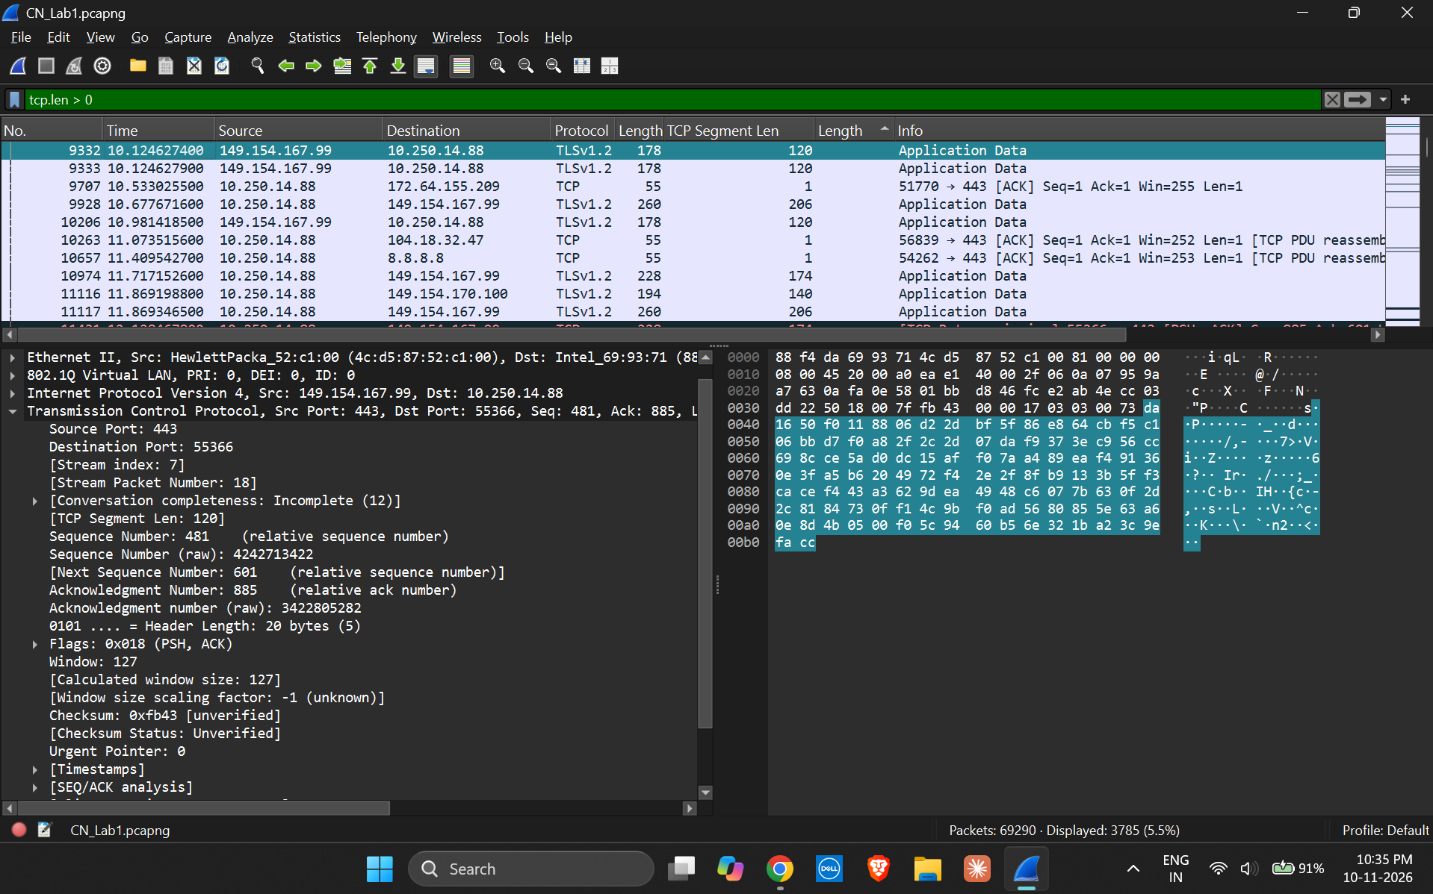
SCREENSHOT 2: TCP PACKET HEADER DETAILS
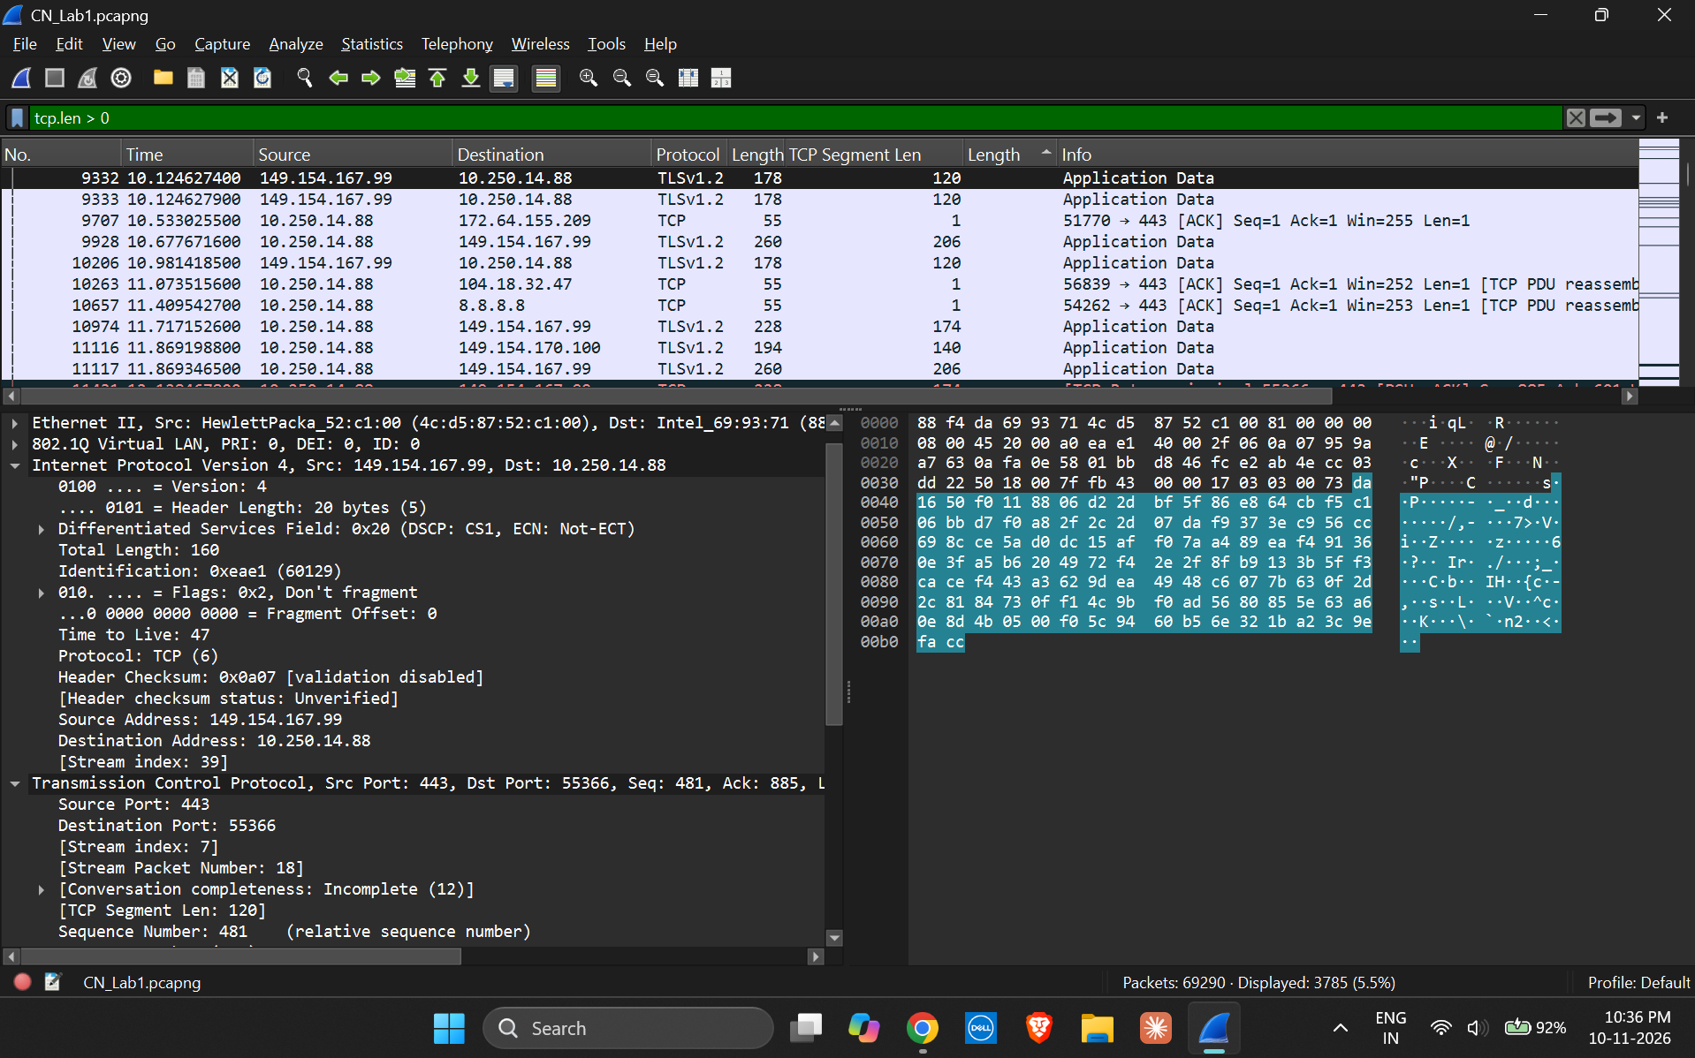

6. UDP PACKET OBSERVATION
UDP packet No. 10622 was selected from the udp.length > 1440 results. The packet list shows a frame length of 1499 bytes. The packet details identify IPv6 as the network-layer protocol, UDP as the transport-layer protocol, a UDP length of 1445 bytes and a UDP payload of 1437 bytes. Therefore, this selected UDP example uses IPv6 rather than IPv4.
Parameter | Observed value
Frame number | 10622
Frame length | 1499 bytes
Ethernet II header | 14 bytes
IPv6 header | 40 bytes
UDP header | 8 bytes
UDP length (header + payload) | 1445 bytes
UDP application-data payload | 1437 bytes

SCREENSHOT 3: UDP PACKET AND HEADER DETAILS
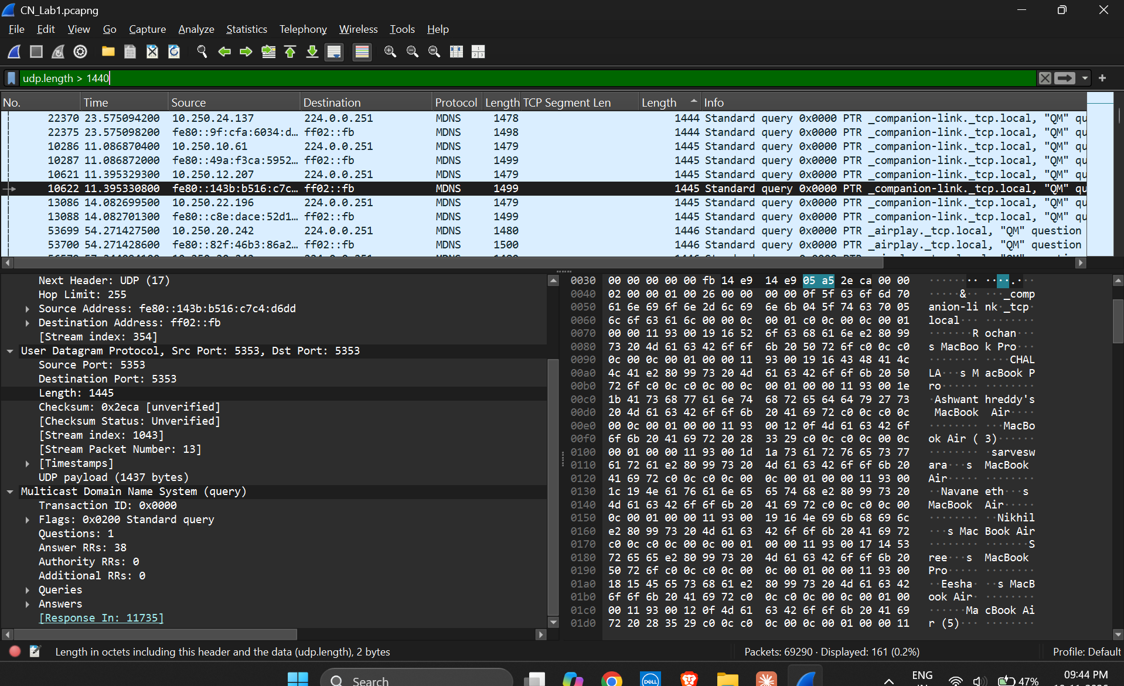

7. UDP OVERHEAD AND PAYLOAD CALCULATION
Total UDP packet header overhead = Ethernet header + IPv6 header + UDP header.
= 14 + 40 + 8 = 62 bytes.
Application payload size = UDP payload = 1437 bytes.
Payload efficiency = (Application payload / Total captured frame length) × 100.
= (1437 / 1499) × 100 = 95.86%.

8. COMPARISON OF TCP AND UDP
Metric | Selected TCP packet | Selected UDP packet
Frame number | 9332 | 10622
Network protocol | IPv4 | IPv6
Total frame length | 178 bytes | 1499 bytes
Total header overhead | 58 bytes | 62 bytes
Application payload | 120 bytes | 1437 bytes
Payload efficiency | 67.42% | 95.86%

For the selected packets, the UDP packet has a higher payload efficiency of 95.86%, compared with 67.42% for the TCP packet. The difference is approximately 28.45 percentage points. The selected UDP packet carries a much larger payload, so its fixed header bytes form a smaller share of the captured frame. The TCP packet has 58 bytes of counted header overhead, while the UDP packet has 62 bytes because the selected UDP example uses a 40-byte IPv6 header.
Note: This is a comparison of the two selected captured packets, not a controlled comparison of TCP and UDP under identical conditions. The selected packets use different network-layer versions (IPv4 for TCP and IPv6 for UDP) and have very different payload sizes. The VLAN tag in the TCP frame is included in its link-layer overhead.

9. RESULT
One TCP data packet and one UDP data packet were inspected in Wireshark. Their header overhead, application payload sizes and payload efficiencies were calculated. The selected TCP packet had 58 bytes of header overhead and 67.42% payload efficiency. The selected UDP packet had 62 bytes of header overhead and 95.86% payload efficiency.

10. CONCLUSION
The activity demonstrated how encapsulation adds headers at the Ethernet, network and transport layers. The calculations showed that payload efficiency depends on the amount of application data carried relative to the total captured frame size. In the selected examples, the UDP packet achieved higher payload efficiency because it carried a substantially larger payload compared with its header overhead. The comparison should be interpreted with the IPv4/IPv6 and packet-size differences in mind.

